# background-image: url

When I use VScode extension "Live Server" to open portfolio.html then Chrome browser only display Helloworld. portfolio.html does not display the image /images/hero-bg.jpg. It seems there something wrong with CSS code

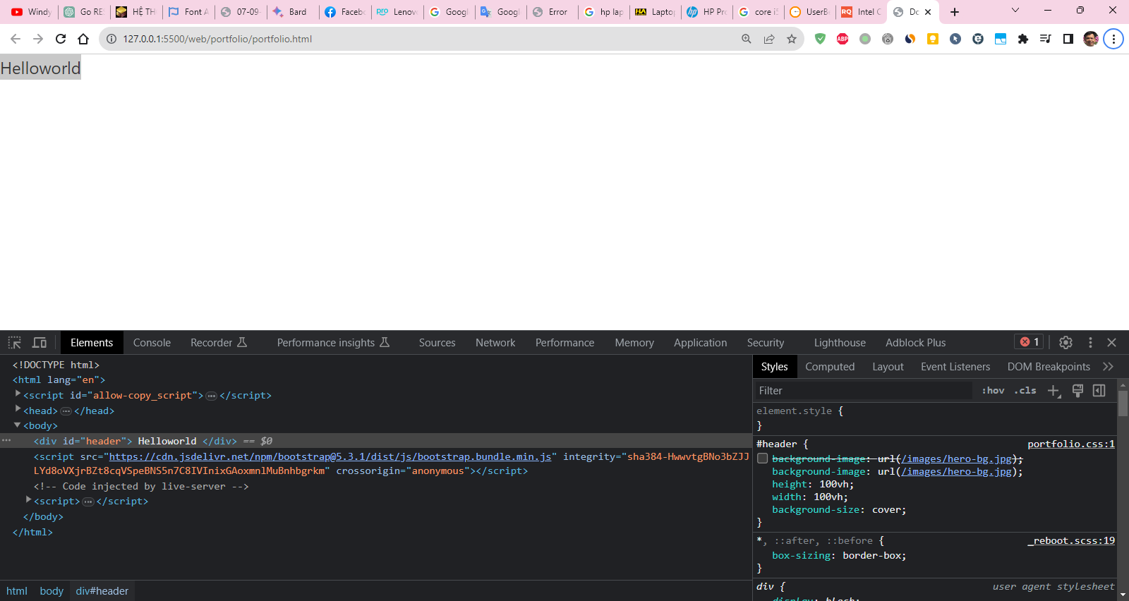

background-image: url("/images/hero-bg.jpg");

Fix the issue.

FYI:

Below is URL on Chrome browser:

http://127.0.0.1:5500/web/portfolio/portfolio.html

Helloworld

thainguyen@756-HOME-PC:/mnt/d/java_course_demo$ ll web/portfolio/portfolio.html

-rwxrwxrwx 1 thainguyen thainguyen 1051 Sep 17 11:30 web/portfolio/portfolio.html

thainguyen@756-HOME-PC:/mnt/d/java_course_demo$ tree web/portfolio/

web/portfolio/

├── css

│ └── portfolio.css

├── hero-bg.jpg

├── images

│ ├── hero-bg.jpg

├── portfolio.html

<!-- BEGIN portfolio.css -->

#header{

    background-image: url("/images/hero-bg.jpg");

    height: 100vh;

    width: 100vh;

    background-size: cover;

}

<!-- END portfolio.css -->

<!-- BEGIN portfolio.html -->

<!DOCTYPE html>

<html lang="en">

<head>

    <meta charset="UTF-8">

    <meta name="viewport" content="width=device-width, initial-scale=1.0">

    <title>Document</title>

    <link href="https://cdn.jsdelivr.net/npm/bootstrap@5.3.1/dist/css/bootstrap.min.css" rel="stylesheet"

        integrity="sha384-4bw+/aepP/YC94hEpVNVgiZdgIC5+VKNBQNGCHeKRQN+PtmoHDEXuppvnDJzQIu9" crossorigin="anonymous">

    <link rel="stylesheet" href="https://cdnjs.cloudflare.com/ajax/libs/font-awesome/6.4.2/css/all.min.css"

        integrity="sha512-z3gLpd7yknf1YoNbCzqRKc4qyor8gaKU1qmn+CShxbuBusANI9QpRohGBreCFkKxLhei6S9CQXFEbbKuqLg0DA=="

        crossorigin="anonymous" referrerpolicy="no-referrer" />

    <link rel="stylesheet" href="./css/portfolio.css">

</head>

<body>

    <div id="header">

        Helloworld

    </div>

    <script src="https://cdn.jsdelivr.net/npm/bootstrap@5.3.1/dist/js/bootstrap.bundle.min.js"

        integrity="sha384-HwwvtgBNo3bZJJLYd8oVXjrBZt8cqVSpeBNS5n7C8IVInixGAoxmnlMuBnhbgrkm"

        crossorigin="anonymous"></script>

</body>

</html>

<!-- END portfolio.html -->

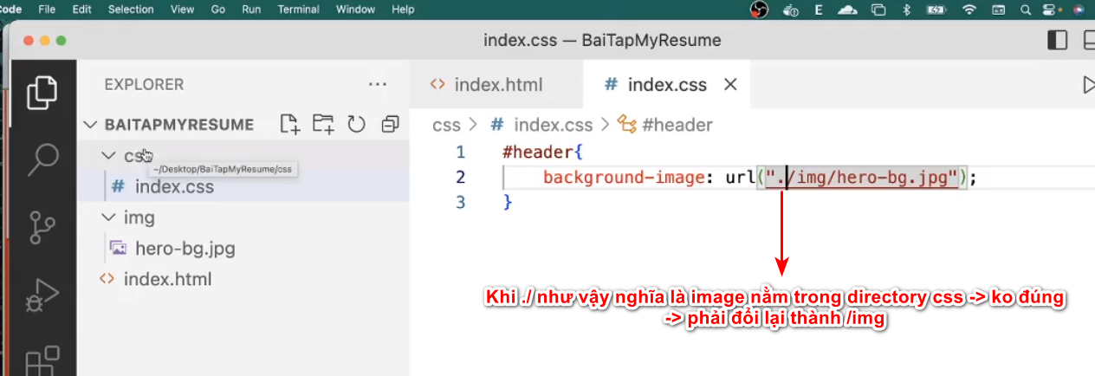

Ans2:

To fix this issue, you need to use an absolute path to the image file. An absolute path starts with the root directory of your website. In your case, the root directory is web/portfolio.

To get the absolute path to the image file, you can use the following code:

**background-image: url("/web/portfolio/images/hero-bg.jpg");**

This will tell the browser to look for the image file in the images subdirectory of the root directory.

Ans1:

One possibility is that the path specified in the CSS is not correctly pointing to the location of the image.

1. Since you're running a local server, the base URL is **http://127.0.0.1:5500/web/portfolio/**.
2. The CSS is looking for the image at **http://127.0.0.1:5500/images/hero-bg.jpg**, which might not be the correct location based on your directory structure.

Given your directory structure:

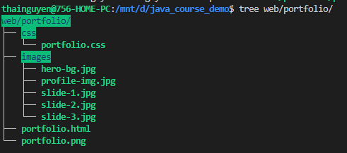

If your CSS is linked in **portfolio.html**, try:

background-image: url("../images/hero-bg.jpg");

Tóm lại 1 trong 2 solution bên dưới work

Hoặc là

    background-image: url("/web/portfolio/images/hero-bg.jpg");

hoặc là

    background-image: url("../images/hero-bg.jpg");

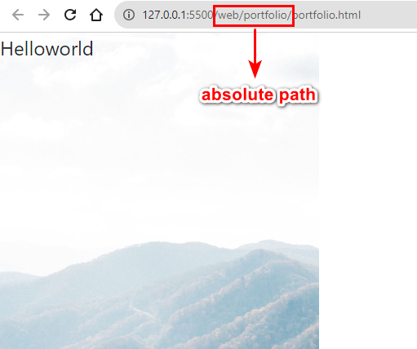



Tips:

Gõ dấu / thì VS code sẽ tự nhắc đường dẫn chính xác

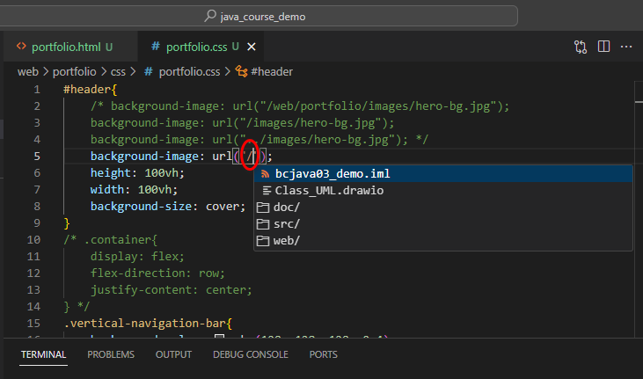

Hoặc gõ ../

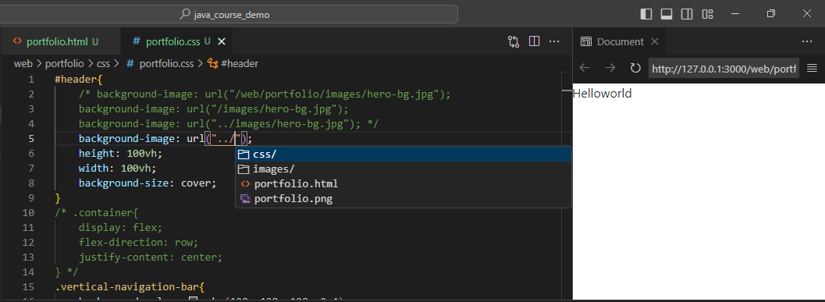

Ans1:

1. **height: 100vh;**: This sets the height of the **#header** element to 100% of the viewport height (**vh**). One unit of **vh** is equal to 1% of the viewport height.
2. **width: 100vh;**: This sets the width of the **#header** element to 100% of the viewport height (**vh**). This might look a bit unconventional, as you're setting the width based on the viewport height, not the viewport width (**vw**).
3. **background-size: cover;**: This property sets how the background image should be resized. The value **cover** scales the background image to cover the entire container, even if it has to stretch the image or cut a little bit off one of the edges.

Ans2:

* height: 100vh; sets the height of the header element to 100% of the viewport height.
* width: 100vh; sets the width of the header element to 100% of the viewport width.
* background-size: cover; sets the background image of the header element to cover the entire element. This means that the image will be scaled up or down to fit the element, and any parts of the image that do not fit within the element will be cropped.

Ans1:

The term "viewport" refers to the user's visible area of a web page, which can vary depending on the device being used to view the content. The viewport height, often abbreviated as *vh*, is a unit that represents the visible height of the user's viewport.

One unit of *vh* is equal to 1% of the viewport height. So, for example:

* 100*vh* is equal to 100% of the viewport height.
* 50*vh* would be 50% of the viewport height.
* 25*vh* would be 25% of the viewport height.

The *vh* unit is particularly useful for creating responsive designs that adapt to different screen sizes. It allows elements to maintain a size proportional to the viewport, ensuring a more consistent appearance across various devices.

Ans2:

Viewport height is the height of the browser window, excluding the browser chrome (such as the toolbar and scrollbars). It is measured in pixels.

Viewport height is an important concept in web design, because it can be used to create responsive layouts that adapt to different screen sizes. For example, you can use viewport height to set the height of a container element to the full height of the viewport, or to center an element vertically within the viewport.

To get the viewport height in JavaScript, you can use the following code:

const viewportHeight = window.innerHeight;

The innerHeight property returns the height of the browser window, excluding the browser chrome.

Here is an example of how to use viewport height to create a responsive layout:

HTML

<div id="container"></div>

CSS

#container {

height: 100vh;

}

This CSS code will set the height of the #container element to the full height of the viewport. This means that the #container element will always fill the entire browser window, regardless of the screen size.

Viewport height is a powerful tool that can be used to create responsive and user-friendly web pages.

# width: 100vh;

#header{

    background-image: url("../images/hero-bg.jpg");

    height: 100vh;

    width: 100vh;

    background-size: cover;

    background-repeat: no-repeat;

}

width: 100vh; WRONG

width: 100vw; RIGHT

width: 100%; RIGHT

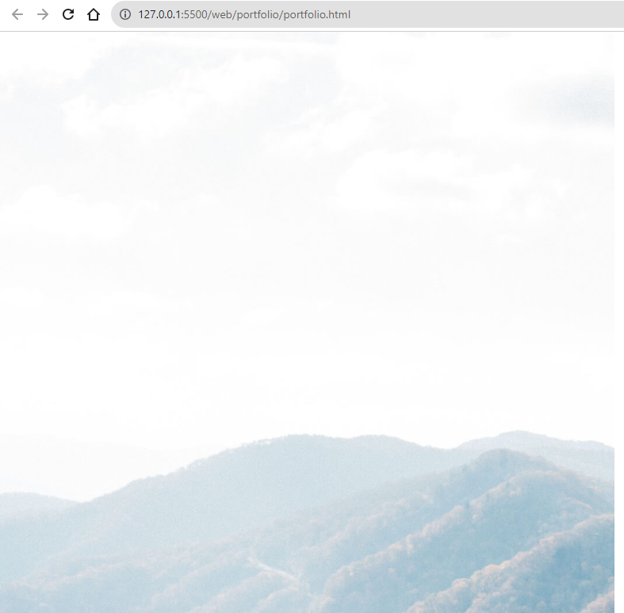

Using width: 100vh would make the width equal to 100% of the viewport height, which doesn't make sense in most cases. Usually, you would set the width to 100% of the viewport width by using width: 100vw or width: 100%.

Here's how you could correct it:

#header {

    background-image: url("../images/hero-bg.jpg");

    height: 100vh;

    width: 100vw;  /* 100% of the viewport width */

    background-size: cover;

}

Or

#header {

    background-image: url("../images/hero-bg.jpg");

    height: 100vh;

    width: 100%;  /* 100% of the parent container's width */

    background-size: cover;

}

Either of these options would make the #header div stretch across the full width of the viewport or its parent container, making it more responsive.